1. 
2. So far, we’ve talked about REST API in theory. The previous unit was mainly about theory and not specific to JAX-RS or really about java. It was about REST API. What is a good design for a REST API? We actually designed REST API.
3. Let’s talk about what JAX-RS is.

In java, we have libraries like library for reading and writing files, library for collection and for XML and JSON.   
Even when developing REST API in java, there are so many REST API libraries. Such as

REST EASY, RESTLET, Jersey etc.  
**NOTE**: We will use Jersey in this course.

1. Actually, you don’t need any REST library. You can write simple server app which can do REST API request and response.  
   But the libraries make the things easier. You don’t have to do yourself.
2. With that said, now the question is which library to choose to learn? If we learn one library, how much effort is needed to learn other one?  
   The good news is that if you learn one you learn all. Each library follows a common interface/API.   
   If you have written your RESTful API using Jersey and want to switch to RESTEASY, just take the Jersey library out and plug-in the RESTEASY Library.  
   So, this common API is called **JAX-RS**. 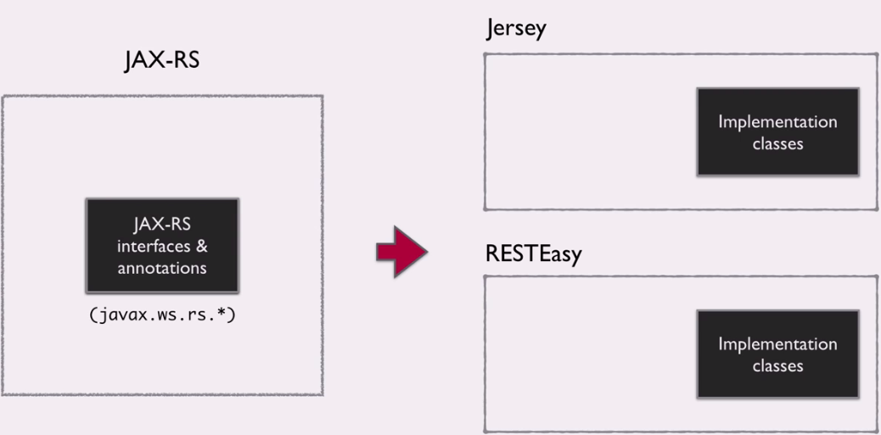 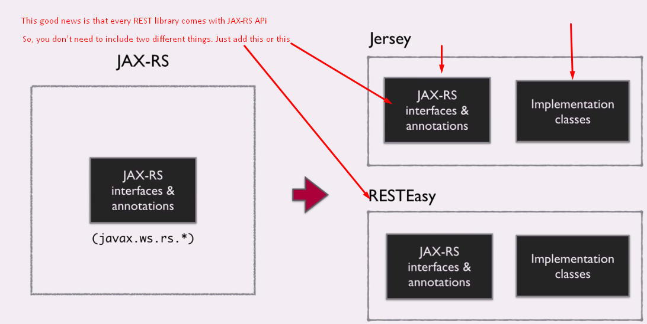 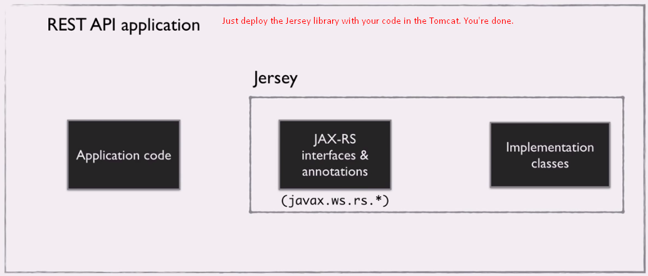
3. 